Risk Management of Public Events
Guidelines for Event Organisers in the Break O’ Day municipality
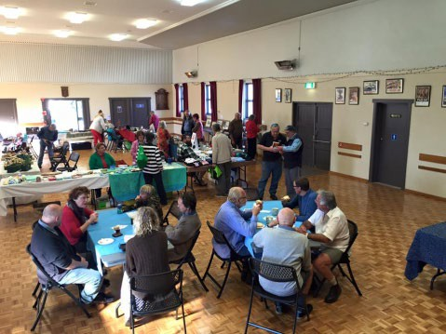
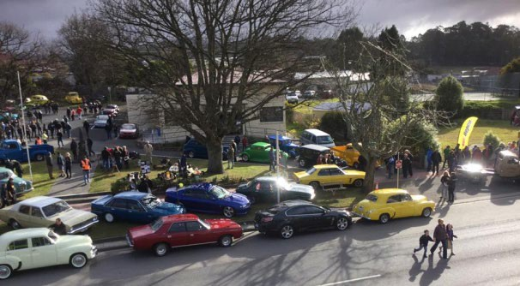
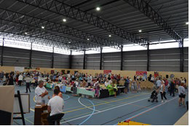
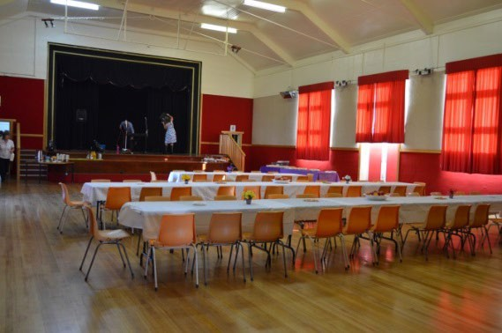
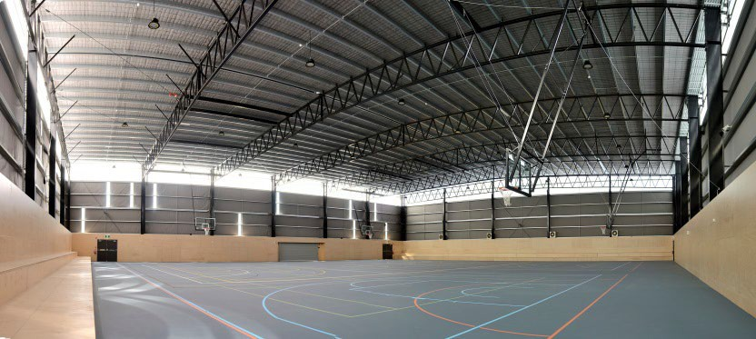
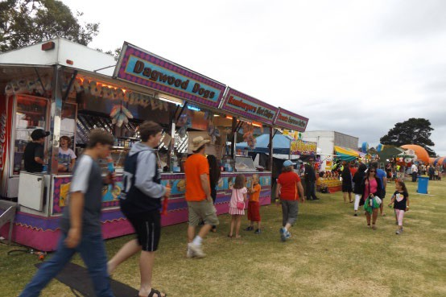


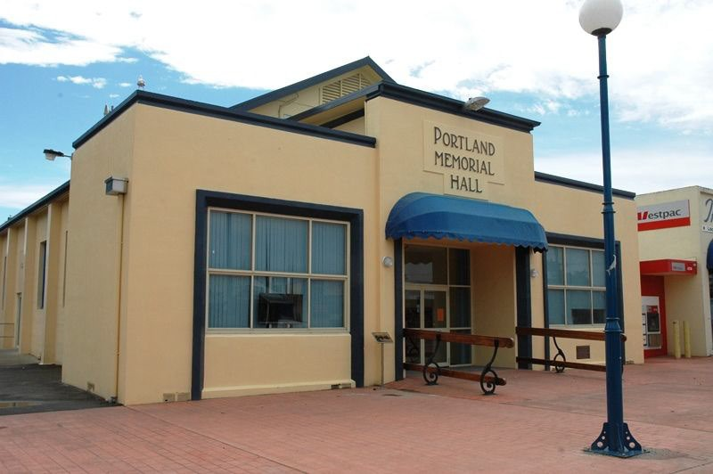
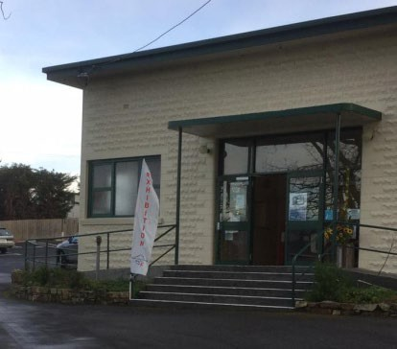
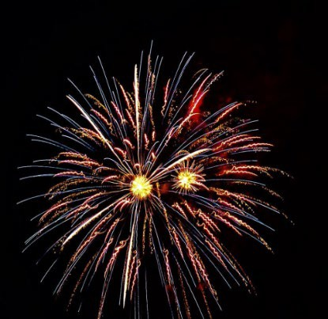
This document is a general guide for Event Organisers to assist in the risk management of their event.
Break O’Day Council does not accept responsibility for any errors, or omissions that may be occurred within this publication. Information in this guide will be subject to change.

Table of Contents
So you are planning an event? 3
Ongoing COVID-19 safety at small to medium events 3
Public Safety and Security 4
Electrical Safety – power and lighting 5
Public Liability Insurance 5
Food 6
Alcohol 6
Toilets 7
Risk Assessment 7
Why do risks need to be managed? 8
How to make your Risk Management Plan? 8
Risk Identification – Example Hazards 8
International Standard for Risk Management ISO 31000:2009 9
Consequence of risk event occurring 10
Risk Analysis Matrix 11
Action Required 11
Strategies for Risk Mitigation / Controls 11
Hierarchy of Controls 12
Table 1: Estimate consequence or severity of impact 14
Table 2: Estimate Likelihood Matrix 14
Table 3: Estimate Risk Level 15
Table 4: Action required 15
Table 4: Evaluating and Treating Potential Risks with examples provided 15

So you are planning an event?
This guide on Risk Management of Public Events was created to support organizing public events within the Break O’Day municipality. The guide covers some crucial aspects to consider while developing a risk management plan for a public event. However, it is not a comprehensive document that encompasses all the issues that event managers might face. It is recommended that the event manager identifies the relevant parts of the guide that apply to their specific event.

The Council is available to provide assistance and guidance to ensure that the event meets all the necessary requirements and runs smoothly. However, the event manager is responsible for seeking additional information where required and obtaining all necessary approvals.
It is important to note that not all information provided in this document may be relevant to every event. Therefore, this guide should be used as a reference only.

Ongoing COVID-19 safety at small to medium events
Events in Tasmania are no longer regulated by specific COVID-19 Public Health Guidelines.
This means there are no requirements for event organisers to submit COVID-19 safety plans and gain approval from Public Health to conduct their events.
However, events must still be conducted safely and following the requirements and recommendations of local government, workplace health and safety regulators, and others.
For the foreseeable future, it is important to act to reduce the chances of COVID-19 spreading at an event. Reducing the risk of COVID-19 spreading at an event is supported by:
- Asking patrons and staff not to attend if unwell
- Providing sufficient space at the event to enable patrons to keep a comfortable distance from each other
- Supporting those who choose to wear a facemask
- Enabling hand washing and sanitising
- Cleaning and disinfecting
- Ensuring the person or team responsible for safety consider and manage COVID-19 risk Public Health has developed guidance to help event organisers to manage COVID-19 safety.
This supports event organisers to understand and implement key actions for COVID-19 safety at events and make the health and safety of staff and patrons the priority.
COVID-19_safety_at_events.pdf (business.tas.gov.au)

Public Safety and Security
The success of an event is often measured by factors such as crowd numbers and economic benefits. The level of safety is also of vital importance to the overall success of any event.

The Event Organiser must provide a safe environment to the public and ensure appropriate care, safety and any training requirements are provided to staff and volunteers involved in running the event.
On-site safety at all events is of the utmost importance with the public expectation being to be able to enjoy your event in safe and secure surroundings. It is the responsibility of the Event organiser to identify and address any potential hazards.
When planning an event you should consider the following items:

- Do you have public liability insurance?
- Is your property and equipment insured?
- Do you have a contact list of all stakeholders?
- Do you have an alternative plan in case of inclement weather?
- Does the location provide adequate shade?
- Are there any exposed power lines that may provide a technical hazard?
- Are there any chemicals or potentially dangerous material stored on the site or nearby?
- Is the area subject to high winds- will marquees and stalls be safe?
- Have you checked to ensure that operators of amusement rides and attractions are qualified and licenced?
- Do you serve alcohol? This may stipulate addressing crowd management and security on site. See page 6.
Regardless of the size of an event, it is necessary to provide a level of first aid. It is the responsibility of the Event Organiser to provide a first aid kit for the duration of the event. Whether you will need a first aid station staffed by a qualified certificate, or a paramedic, and a medical facility, will be determined by the type of event, the number of patrons expected to attend and any perceived risks.
For example, a low-risk event of around 200 attendees requires one first aid officer to be on-site at all times.
Patrons | First  Aiders | First Aid  Posts
Less than 500 | 1 | 1
500 or more | 2 | 1
1,000 or more | 4 | 1
2,000 or more | 6 | 1
5,000 or more | 8 | 2
10,000 or more | 12 | 2
The above is a guidance based on information provided in the Planning Guide for Event Managers, Victoria.

Electrical Safety – power and lighting
The Event Organiser is responsible for arranging the supply and installation of any electrical/power requirements for the event, such as the use of generators, extension cords and cables.

It is important to ensure that:
- electrical leads do not create trip hazards. No cables are to lie on the ground unless adequately protected as they can present a serious hazard;
- lead joints and connections are not to be accessible to the public or exposed to damp conditions;
- temporary electrical leads must be flexible cables;
- double adaptors and piggy-back plugs are not to be used;
- all electrical equipment including power cords/leads used in ‘hostile operating environments¹’ should be inspected and tested by a competent person (i.e. a licensed or registered electrician, a licensed electrical inspector or a person who has completed a structured training course and has been deemed competent) at least once every 12 months and have a tag attached to the tested electrical equipment specifying:
  - the name of the person who carried out the testing,
  - the date of the testing, and
  - the date on which the next testing must be carried out.

Please note that brand-new equipment that is ‘out of the box’ does not need to be tested before being put into service unless there are reasonable grounds to believe it is electrically unsafe.
The Event Organiser must ensure that any unsafe electrical equipment within their management or control is disconnected or isolated from the Council’s electricity supply and once disconnected is not reconnected until it is repaired or tested and found to be safe or is replaced or permanently removed from use.
Should you require further information including a copy of the WorkSafe Australia fact sheet on electrical risks visit https://www.safeworkaustralia.gov.au/resources-and-publications/information-sheet/electrical-risks- workplace-fact-sheet.

Public Liability Insurance
It is essential when managing a public event that the event and the event organiser have adequate public liability insurance coverage.
- A festival or event should be managed by an incorporated body to ensure that any liabilities are enforceable against the organisation itself, rather than committee members personally.

1 ‘Hostile operating environment’ describes an environment where electrical equipment is exposed to operating conditions that are likely to result in damage to the equipment or a reduction in its expected life span. This includes conditions that involve exposing the electrical equipment to moisture, heat, vibration, mechanical damage, corrosive chemicals and dust.

- If the event is not run by an incorporated organisation, the event should be auspices (covered under another’s insurance) by an appropriate organisation. For further information about what auspicing is, visit: www.nfplaw.org.au/auspicing
- If other companies are involved in your event such as amusement providers, they should have their own insurance coverage. Organisers of an event should collect a copy of their stallholder's Certificates of Currency. This is a piece of mind that in the unlikely case of something going wrong, any liability can be directed to the stall holder at fault.
- For quotes on insurance for community groups, visit: www.localcommunityinsurance.com.au

Food
Food plays a crucial role in any event, and it should align with the event theme and schedule. It is important to ensure safe food handling practices at events to minimize potential health risks and provide satisfactory food services to the attendees.

To provide low-cost catering alternatives, community groups can be involved in catering. Mobile food vendors are another option that can provide food and drinks on a user-pays system.
Any individual or business providing food for public consumption must have an applicable food permit. Yearly food permits are available, which allow vendors to serve food anywhere in the state. Vendors without a yearly permit must obtain an individual permit for each event.
To comply with regulations, a list of all food vendors and their contact details should be provided to the Council by including them in the Event Application and submitting copies of their Certificate of Registration and Certificate of Currency.

Alcohol
If you plan to sell alcohol at your event, you must obtain permission from the Licensing Commission, a branch of the Department of Treasury and Cabinet.
- A Temporary Liquor Licence may be applied for from the Licensing Commission and a copy provided to Council. Applications can be downloaded from www.treasury.tas.gov.au
- Alcohol must be served responsibly - whoever holds the licence must ensure that procedures are in place to do so.
- Consumption of alcohol will affect the number of toilets that you must have available for patrons - check the chart for details.
- Alcohol must be served in a fully enclosed bar area.

The availability of alcohol can add another layer of complexity to your event. You might also want to consider the following if you are selling or providing alcohol at your event.
- Ensuring drinks are only served in plastic vessels
- Engaging additional security to deal with any anti-social behaviour
- Consider the age of the patrons at your event, bearing in mind that alcohol must not be served to those under 18 years of age

Toilets
Adequate toilet facilities need to be available for patrons at your event. If there are insufficient public facilities available, portable toilets will need to be brought in and paid by the event organiser/s.
Points for consideration are:
- Location of the toilets within your site plan
- Accessibility for parents with small children and people with limited mobility
- Cleaning and supply roster to ensure toilet supplies are restocked and cleaned during your event
- How the wastewater will be managed

As a guide, for events without alcohol, the following is required:
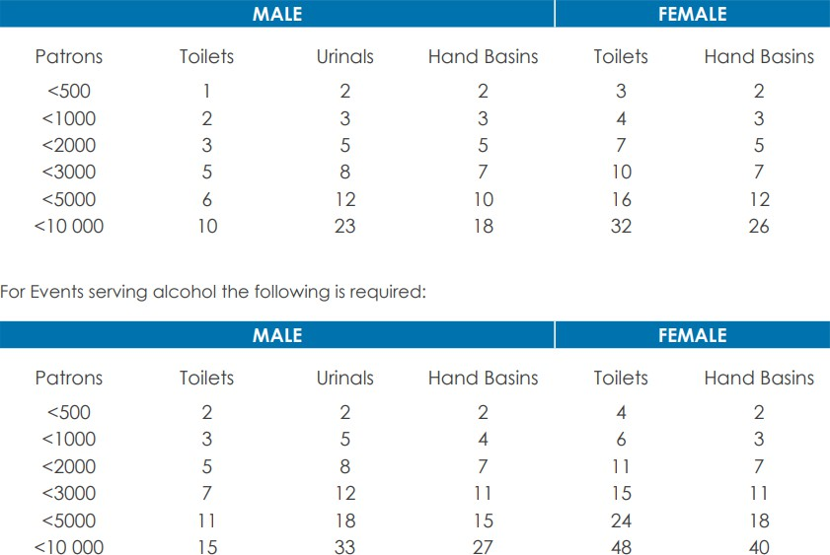

Risk Assessment
For Event Organisers to meet their duty of care, comprehensive event safety planning is required. Risk assessment and management form part of this process.
The principles of risk assessment and risk management involve the systematic use of available information to determine how often incidents may occur and the magnitude of their likely consequences.
A basic risk analysis for a place of assembly should consider:

- How likely is an incident to happen; and
- What are the potential consequences and their magnitude?

Why do risks need to be managed?
- To reduce unexpected and costly surprises;
- More effective and efficient allocation of resources;
- More informed decision making;
- Compliance with regulatory requirements;
- A well-organised event will encourage greater participation; and
- Difficulties may arise in the event of an accident when making an insurance claim and the risk has not been managed well by the organiser.

How to make your Risk Management Plan?
- Identify the potential risks for your event, see the example hazards list.
- Assess the Likelihood for each risk, see ‘risk analysis matrix on page 4’.
- Assess the Consequences for each risk.
- Describe Mitigation Strategies for each particular risk.
- Nominate the Responsible Person for each particular risk.
- Keep a record of your plan and reassess the risk if the scope of the event changes.

All of this information is best captured on pages 5 and 6 in this guide.

Helpful Resources
Workplace Standards Tasmania Code of Practice for Risk Management of Agricultural Shows and Carnivals is available at www.wst.tas.gov.au.

Risk Identification – Example Hazards
The checklist items can be used as a prompt. You will also need to consider site and event-specific risks.
EXAMPLE OF HAZARDS
PEOPLE | HAZARDOUS MATERIAL
Disorderly unruly behaviour  Public accessing non-public areas of the event Misuse of amusement and rides  Drug and/or Alcohol affected persons Criminal activity  Overcrowding Terrorism/ Bomb threat  Medical Emergency (e.g. heart attack) Lost children  Water hazard – drowning  Lack of patron awareness of facility locations | Chemical hazards Pyrotechnics / Fireworks  Fuels e.g. Petrol, LPG gas heating in community halls, Diesel

EXAMPLE OF HAZARDS
TRIP / SLIP HAZARDS | TECHNICAL MANAGEMENT
Electrical cables  Uneven ground, loose surfaces Flooring design/surface Lighting  Climbing for vantage points Temporary fencing  Spills on the floor during the event | Inadequate site management Lack of staff briefing Communications failure Power failure  Water failure Toilet failure  Unregistered food vendors Unsafe temporary structures Extreme weather Electrocution / shorting out Fire
HEALTH | VEHICULAR
Food poisoning Disease outbreak  Animal to human spread of disease Excessive noise levels  Inadequate number of toilets Inadequate maintenance of toilets Sunburn/dehydration  Smoking | Disabled parking  Lack of parking spaces Traffic congestion Collisions  Emergency services access
ACCESSIBILITY | WASTE
Inadequate seating space Inaccessible toilet facilities  Difficulty touring through the event site | Insufficient rubbish bins  Inadequate emptying/cleaning of bins  Litter collection

International Standard for Risk Management ISO 31000:2009 CORE INFRASTRUCTURE RISK MANAGEMENT PLAN
IDENTIFY RISKS
What can happen?
When & why? How & why?
ANALYSE RISKS
Controls Consequence Likelihood Evaluate
TREAT RISKS
Identify options Assess solutions Prepare plan
MONITOR AND REVIEW

Takes into account the LIKELIHOOD of a risk event occurring
LIKELIHOOD | DESCRIPTOR
Rare | Unlikely to occur during the next 25 years
Unlikely | May arise once in 10 to 25 years (Recurrent Event)  Unlikely but not impossible 10-29% (Single Event)
Possible | May arise about once in 10 years (Recurrent Event)  Less likely than not but still possible 30-69% (Single Event)
Likely | May arise about once per year (Recurrent Event)  As likely is not 70-89% (Single Event)
Almost certain | Could occur several times per year (Recurrent Event)  More likely than not 90-99% (Single Event)
Consequences of a risk event occurring can include:
- Repair costs ▪ Loss income
- Loss of life/injury ▪ Health impacts
- Damage to property ▪ Failure to meet statutory requirements
- 3rd party losses ▪ Loss of image

Consequence of risk event occurring
CONSEQUENCE | INJURY | PUBLIC SAFETY | FINANCE | COMMUNITY & LIFESTYLE | ENVIRONMENT & SUSTAINABILITY
Insignificant | No injuries | Appearance or threat but no actual harm | Low loss < or equal $5,000 | Minor areas in which the municipality unable to maintain current services | No damage
Minor | First Aid treatment | Serious near misses or minor  injuries | Medium loss < or equal to  $50,000 | Isolated noticeable examples of the decline in services | Minor instances of environmental damage  that could be reversed
Moderate | Medical treatment required | A small number of injuries | High loss < or equal to  $500,000 | The general appreciable decline in services | Isolated but significant instances of  environmental damage that might be reversed  with intensive efforts.
Major | Extensive injuries | Isolated  instances of serious injuries or  loss of lives | Major loss < or equal to  $1M | Severe and widespread decline in services and quality of life within the community | Severe loss of environmental amenity and danger of continuing  environmental damage.
Catastrophic | Death | A large number of serious injuries or loss of lives | Huge loss < or equal to $4M | The municipality would be seen as very unattractive, stagnant and unable to support its  services | Major widespread loss of progressive irrecoverable environmental damage

Risk Analysis Matrix
RISK RATING
LIKELIHOOD | CONSEQUENCES
LIKELIHOOD | Insignificant | Minor | Moderate | Major | Catastrophic
Almost Certain | MEDIUM | MEDIUM | HIGH | EXTREME | EXTREME
Likely | LOW | MEDIUM | HIGH | HIGH | EXTREME
Possible | LOW | MEDIUM | MEDIUM | HIGH | HIGH
Unlikely | LOW | LOW | MEDIUM | MEDIUM | MEDIUM
Rare | LOW | LOW | LOW | LOW | MEDIUM

Action Required
 | RISK RATING | ACTION REQUIRED
EXTREME | Extreme Risk | Immediate corrective action
HIGH | High Risk | Prioritised action required
MEDIUM | Medium Risk | Planned action required
LOW | Low Risk | Managed by routine procedures

Strategies for Risk Mitigation / Controls

Step 1  What can I do to prevent the realisation of the risk?  In other words, what can you do to reduce the likelihood of the risk occurring? | Can you eliminate the risk?  Carefully evaluate the element that poses the risk.  Is it critical to the event? Could it be removed and still allow the objectives of the event to be achieved?  Can you substitute the process or material that will prevent the risk?  Investigate what others do. Consider alternative methods or elements that may  enable you to avoid the risk and still achieve the even objectives.
Step 2  What can I do to prepare or respond to the risk if it occurs? In other words, if the risk were to occur, what can you do to reduce  the consequences? | Can you engineer the facility or equipment to prevent the risk?  Careful design, good construction and the right materials can prevent risk from eventuating.  Can you introduce administrative measures that will prevent the risk?  There are many administrative tools used to prevent risk. Rules, guidelines, policies, checklists, communication systems, training, emergency response plans, etc.
Step 3  What can I do to recover from the risk if it occurs?  In other words, are there things you can do to respond to the event that is directed more at the survival of the event or organisation? | What personal responsibility can you reasonably ask in preventing the risk? How much risk will people be prepared to accept to be part of the event?  How much is it reasonable to ask them to accept?  What protective equipment could people wear to prevent the risk? Helmets, gloves, hats, sunscreen, safety footwear, eye protection, etc.  What can you do to transfer the risk? Insurance.  Is it possible for the risk to be financed? Establishing a fund that covers losses to a certain level.

Hierarchy of Controls
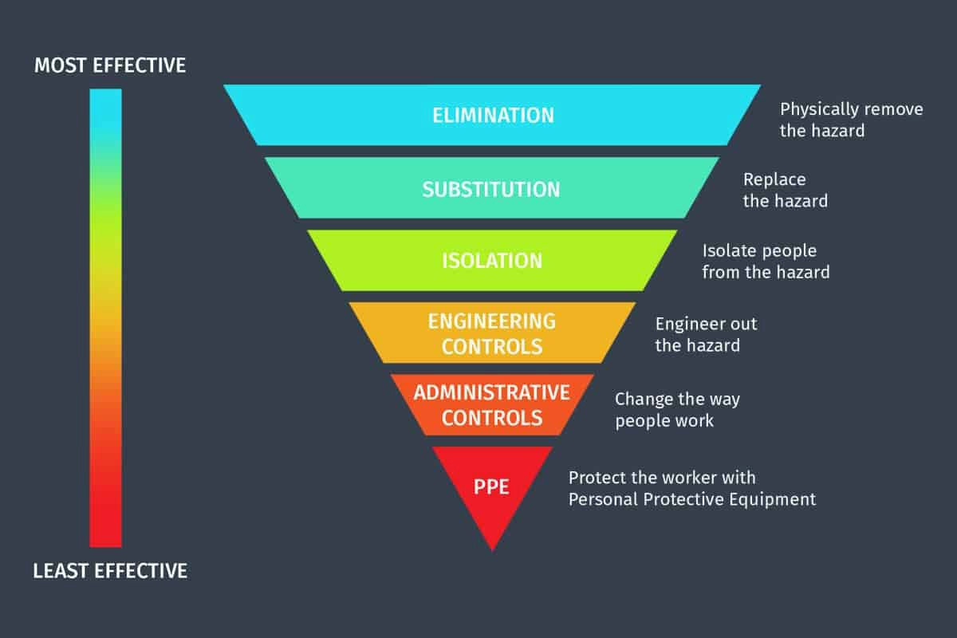

EVENT RISK ASSESSMENT
Name of event: |  | Location of event:
Date Event Starts: Date Event Finishes: |  | The event is open between the following hours:
Date Setting Up for Event: |  | Time  From: |  | Time  To:
Target audience: |  | Expected audience number:
Event Manager: |  | Organisation:
Mobile number during the  event: |  | Has a map or layout been  provided to the Council? |  | Yes No N/A
Road closure required:  You will need to apply for an Application for a Temporary Road Closure of a public  street. | Yes No N/A | Name of road(s):
Has a permit been issued? | Yes No N/A | Have the emergency services been notified of the road  closure? |  | Yes No N/A
Fireworks/Pyrotechnics?  You must apply and gain approval from Workplace Standards Tas, notify the Council of your approval and receive permission from the  land owner. | Yes No N/A | Has a permit been obtained?  Visit www.worksafe.tas.gov.au or call 1300 366 322 |  | Yes No N/A
Who will supply first aid?  (Contact details) |  | Number of First Aid Posts and Personnel during the event:

Table 1: Estimate consequence or severity of impact
WHAT ARE THE CONSEQUENCES (CONSEQUENCE RATING)
CONSEQUENCE | INJURY | PUBLIC SAFETY | FINANCE | COMMUNITY & LIFESTYLE | ENVIRONMENT & SUSTAINABILITY
Insignificant | No injuries | Appearance or threat but no actual harm | Low loss < or equal $5,000 | Minor areas in which the municipality is unable to maintain current services | No damage
Minor | First Aid treatment | Serious near misses or minor injuries | Medium loss < or equal to  $50,000 | Isolated noticeable examples of the decline in services | Minor instances of environmental damage that could be reversed
Moderate | Medical treatment required | A small number of injuries | High loss < or equal to  $500,000 | A general appreciable decline in services | Isolated but significant instances of environmental damage that might be reversed with intensive efforts.
Major | Extensive injuries | Isolated instances of serious injuries or loss of lives | Major loss < or equal to $1M | Severe and widespread decline in services and quality of life within the community | Severe loss of environmental amenities and danger of continuing environmental damage.
Catastrophic | Death | A large number of serious injuries or loss of lives | Huge loss < or equal to $4M | The municipality would be seen as very unattractive, stagnant and unable to support its services | Major widespread loss of progressive irrecoverable environmental damage

Table 2: Estimate Likelihood Matrix
LIKELIHOOD OF THE RISK OCCURRING
LIKELIHOOD | DESCRIPTOR
Rare | Unlikely to occur during the next 25 years or  The event may occur only in exceptional circumstances; rare exposure to risk; very low probability of damage s
Unlikely | May arise once in 10 to 25 years (Recurrent Event)  Conceivable but not likely to occur under normal operations. Infrequent exposure to risk; low probability of damage; little or no history of previous incidents
Possible | May arise about once in 10 years (Recurrent Event)  The event could occur at some time; regular or occasional exposure to risk; moderate probability of damage
Likely | May arise about once per year (Recurrent Event)  The event will probably occur at some stage; frequent exposure to risk; substantial probability of damage; some history of previous incidents
Almost certain | Could occur several times per year (Recurrent Event)  The event Is expected to occur most times during normal operations; constant  exposure to risk; high probability of damage; clear history of previous incidents

Table 3: Estimate Risk Level
RISK RATING
LIKELIHOOD | CONSEQUENCES
LIKELIHOOD | Insignificant | Minor | Moderate | Major | Catastrophic
Almost Certain | MEDIUM | MEDIUM | HIGH | EXTREME | EXTREME
Likely | LOW | MEDIUM | HIGH | HIGH | EXTREME
Possible | LOW | MEDIUM | MEDIUM | HIGH | HIGH
Unlikely | LOW | LOW | MEDIUM | MEDIUM | MEDIUM
Rare | LOW | LOW | LOW | LOW | MEDIUM

Table 4: Action required
EXTREME | High Risk  Immediate action is to be initiated to implement controls as outlined in the Risk Assessment.  Event Organiser to determine further action if required.
HIGH | Significant Risk  Attend to in the short term. Implement controls as outlined in Risk Assessment. Event Organiser to determine further action if required.
MEDIUM | Moderate Risk  Attend to in the medium term. Implement controls as outlined in the Risk Assessment
LOW | Low Risk  Develop or modify procedures to address the risk and implement controls as outlined in Risk Assessment.

Table 4: Evaluating and Treating Potential Risks with examples provided

Please complete the risk prompts if they apply to your event otherwise note Not Applicable N/A.
Risk | Likelihood | Consequence | Risk Level | Mitigation Strategies/Controls | New Risk Level | Person Responsible
People
Disorderly spectators &/or conflict | Unlikely | Insignificant | LOW | Advise the patron/spectator to leave. Call the Police for assistance if needed. | LOW | Event Organiser
Drug or alcohol- affected person
Trip Hazards
Spills & subsequently slips during the event | Rare | Minor | LOW | The hirer/event organiser is responsible for cleaning up any spills during and after the event with the cleaning equipment provided by the  Council. | LOW | Event Organiser

Risk | Likelihood | Consequence | Risk Level | Mitigation Strategies/Controls | New Risk Level | Person Responsible
Trip Hazards - continues
Health
Medical Emergency | Unlikely | Moderate | MEDIUM | Events first aid officer to assist and | LOW | Event
e.g. patron |  |  |  | call an ambulance. |  | Organiser &
suffering a heart |  |  |  |  |  | First Aid
attack |  |  |  |  |  | Officer
Food poisoning
Hazardous Material
LPG heating in St Marys Hall caused a fire | Rare | Major | LOW | Only the Event Organiser is responsible for turning the heaters on and off. | LOW | Event Organiser
Damage to | Unlikely | Major | MEDIUM | Follow Council’s Fast Facts about | LOW | Event
Council’s building |  |  |  | BBQ & Gas Cylinder Safety. |  | Organiser
due to an explosion |  |  |  | Gas BBQ should not be operated
of a BBQ gas |  |  |  | inside a Council building/hall. Don’t
cylinder |  |  |  | position it near a fire exit door, side
 |  |  |  | entrance or walkway. The clearance
 |  |  |  | between a gas cylinder and the
 |  |  |  | building must be at least 3 metres.
Debris/sharps on event ground
Technical Management
Power failure | Rare | Minor | LOW | Cancel the event if a power failure occurs. Contact Council and/or TasNetworks to ascertain if the power failure is specifically to the building or in the township. | LOW | Event Organiser
Water failure | Rare | Minor | LOW | Determine if the problem is specific to the building or elsewhere. Contact Council and/or TasWater regarding the situation. | LOW | Event Organiser

Risk | Likelihood | Consequence | Risk Level | Mitigation Strategies/Controls | New Risk Level | Person Responsible
Fire | Rare | Major | LOW | Cancel the event if a fire occurs. Follow Standard Fire Order posters affixed near the entrance to the hall and evacuate the building. Call the Fire Brigade on 000 and contact the Council. | LOW | Event Organiser
Technical Management – continues
Electrocution due to electrical equipment being used was NOT been tested and  tagged | Unlikely | Catastrophic | MEDIUM | A qualified professional has conducted thorough testing and tagging of the electrical equipment that is used in the Council’s buildings. | LOW | Event Organiser
Noise pollution for concerts and events > 500  people |  |  |  | Develop a noise management plan and submit it to the Council’s Environmental Health Officer.
Vehicular
Lack of parking
Vehicles vs pedestrians
Waste
Rubbish (during and after the event)
Unclean toilets
Accessibility
Inadequate access to emergency vehicles

Risk | Likelihood | Consequence | Risk Level | Mitigation Strategies/Controls | New Risk Level | Person Responsible
Event / Site / Specific Risks
Structure or marquee collapse
Overcrowding
Event / Site / Specific Risks - continues
Extreme weather or high winds
Fire Pits on grassed areas

I / We (please print full name/s)
(Event Manager/s)

represent (name of the organisation)
acknowledge the risks associated with the proposed event and comply with the mitigations listed in the risk assessment plan.
Event Manager/s Signature/s

Date:

